##$$kk About

PT 5201 Compact Varitime™ Sync Generator

Version: 1.4
Date: 18-03-2001/GBg

Copyright DK-Audio DK
Marielundvej 37 D
2730-Herlev -Denmark
Phone: +45 4485 0255; Fax: +45 4485 0250
Website: www.ptv.dk or www.dk-audio.com

Menu Structure
The menus under Files are similar in nature to other Windows® applications. Here are menus featuring opening and saving presets and files. Furthermore the RS232 interface communication details and lock of calibration and editing are handled here.

This is a link to Connect Using PC Settings

##$$kk Files|Open|from File

Opening an already existing file will read the settings into the Windows® interface and give a connected unit the same set of settings.

##$$kk Files|Open|from Preset

Opening an already existing preset will read the settings into the Windows® interface and give a connected unit the same set of configuration leave the unit in the given preset status

##$$kk Files|Save|to File as

To Save To File will load the current configuration into a file on the harddrive. The file can be read by the Windows® applications only and can be given any name.

##$$kk Save|to Preset

To Save To Preset enables you load the current configuration into the memory of the connected unit. The preset can be given a name and a date and these data will be recognized by the Windows® interface. The unit can hold 4 different configurations in its preset bank and these can be selected from the front panel.

Each preset is identified by:
Name (24 characters, no space)
Author
Date of modification

##$$kk Files|Print

No help available. This function not implemented.

##$$kk Files|Properties

The Properties menu serve as control for the RS232 interface communication details and calibration and editing lock.

Connection
The connection menu enables you to modify the status of the RS232 interface communication port and indicate the default Baud rate and Flow Control. In the Port settings the communication port is selectable from COM1-COM4.

System:
Checking the Lock Editing option will disable editing of the PT5201. Checking the Lock Calibration will disable user calibration.

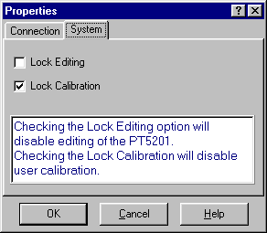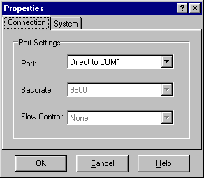

##$$kk Connect|Using|Generator Settings

The Connect Using menu opens the communication between the Windows® interface and a unit connected. The communication between the Windows® interface and the unit can be established in two modes depending on operation.
The communication can be established by the Windows® interface reading the current settings of the unit, using Connect Using/Generator Settings. To open the communication click on the desired function.

##$$kk Connect|Using|PC Settings

The Connect Using menu opens the communication between the Windows® interface and a unit connected. The communication between the Windows® interface and the unit can be established in two modes depending on operation. The communication can be established by the Windows® interface writing its current/last settings, using Connect Using/PC Settings. To open the communication click on the desired function.

##$$kk Connect|Disconnect

Disconnect is used to abort communication between the Windows® interface and a connected unit before disconnecting the interface cable

##$$kk Connect|Demo Mode

The Demo Mode is a way to demonstrate or operate the Windows® interface off line (no PT 5201 unit attached). Running the Windows® interface in Demo Mode give access to all the output features of the unit and access to store a set-up as a file. A set-up saved as a file can be uploaded to the unit at any time, when a unit is connected.

##$$kk Edit | Genlock

The Genlock facility enables you lock all outputs of the PT 5201, to a number of relevant video and clock sources. The outputs of PT 5201 are locked to the source in frequency and phase.

System:
System refers to the list of relevant video and clock sources PT 5201 is able to use as external reference.
PAL Burst and NTSC Burst mode PT 5201 will expect a video signal of the given system.

Internal mode: all outputs of PT 5201 are locked to the internal high stability TCXO oscillator.

10 MHz mode: the source is expected to be a 10 MHz reference. The internal oscillator will be locked to the reference and PT 5201 will act as in Internal Mode. Due to the internal reference the timing feature is disabled.

When the reference source is valid and the oscillator circuit is in lock, the ”Genlocked” LED on the front panel, will be lit.

Timing:
All outputs of PT 5201 are timeable with reference to the Genlock video signal. All output is timed in parallel in resolution of the individual output.

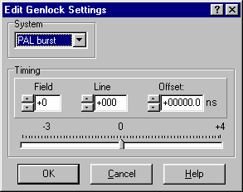##$$kk Edit | BB

All three Black Burst outputs are digitally generated under the VariTimeTM system and are independent in timing and generation of TV system (NTSC/PAL).

Black Burst:
Black Burst x (BB1 to BB3) is digitally generated under the VariTimeTM system and is independent in timing and generation of TV system (NTSC/PAL). The VariTimeTM system has a resolution of 0.15 ns and the timing range of 4 fields for NTSC and 8 fields for PAL.

System:
The VariTimeTM outputs are able to generate Black Burst both in TV systems, NTSC and PAL.

Timing:
The VariTimeTM outputs are generating Black Burst with a resolution of 0.15 ns and the timing range of 4 fields for NTSC and 8 fields for PAL.

Field, Line, Offset:
Edit of the number of Fields, Lines or Offset of ns to be advanced or delayed can be done in 3 ways:
- The modifications are typed directly in the edit boxes using number keys and sign. Typed values are truncated to valid timing intervals.
I- ncrementing or decrementing by the up/down buttons, or using the timing bar.
- Using the timing bar by grabbing the pointer with the mouse cursor and moving it, for quick timing.

ScH-Phase:
The VariTimeTM system features adjustment of the ScH-Phase in the range of ±180º in a resolution of 1º, operated using the up/down buttons, or typed in directly.

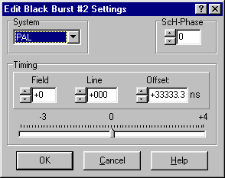

##$$kk Edit | TSG

The Test Signal Generator contains 23 basic patterns and signals, including Color Bars for the respective TV systems. The TSG outputs signals in two formats simultaneously, Analog Composite (TSG output) and SDI (SDI output) and has a common of 4 or 8 fields timing range in 37 ns resolution. The SDI output features separate settings for embedded audio. The Analog Composite output features ScH-Phase adjustment in 1º resolution.

System:
The TSG and SDI output generates patterns in both NTSC/525 lines and PAL/625 lines systems. One common system for both output at a time.
Timing:
The VariTimeTM outputs are generating Black Burst with a resolution of 37 ns and the timing range of 4 fields for NTSC and 8 fields for PAL.

Field, Line, Offset:
The VariTime™ unit is generating Analog and Digital test signal outputs with a resolution of 37 ns and the timing range of 4 fields for NTSC and 8 fields for PAL.
Field, Line and Offset can be modified within their relevant limits.
Edit of the number of Fields, Lines or Offset of ns to be advanced or delayed can be done in 3 ways:
- The modifications are typed directly in the edit boxes using number keys and sign. Typed values are truncated to valid timing intervals
- Incrementing or decrementing by the up/down buttons, or using the timing bar.
- Using the timing bar by grabbing the pointer with the mouse cursor and moving it, for quick timing.

ScH-Phase:
The VariTimeTM system features adjustment of the ScH-Phase in the range of ±180º in a resolution of approx. 1.4º, operated using the up/down buttons, or typed in directly.

Pattern:
The Test Signal Generator contains 21 basic patterns and signals, including Color Bars for the respective TV systems.
The list of signals consists of 19 patterns for NTSC and 21 patterns for PAL.
The TSG outputs signals in two formats simultaneously, Analog Composite (TSG output) and SDI (SDI output).

Analog Settings:
The Analog Composite output features common timing and ScH-Phase adjustment in 1º resolution.
SDI Settings:
The SDI output features common timing and separate settings for embedded audio.

ScH-Phase:
The Analog Composite output features adjustment of the ScH-Phase in the range of 3 180º in a resolution of approx.1.4º.

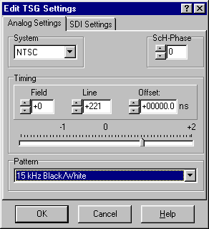

##$$kk Edit | Audio

PT 5201 contains two independent audio generators, Analog Audio and AES/EBU digital audio and a WordClock output (WCLK).
Due to common rear connectors, only one audio generator can be active at a time.
The AES/EBU generator features selectable sample rate, video reference lock, timing and a number of tones and levels.
The Analog Audio generator features four tones in a large number of levels and right channel identification.

Output
Selectable between Analog audio and digital AES/EBU.
Some of the fields in the menu may be greyed out, indicating that this parameter is not valid for that format.

System
In Genlocked mode the AES/EBU generator locks to both video systems and in Internal mode the audio generator is locked to the internal reference.

Timing
Editing can be done in 3 ways.
The modifications are typed directly in the edit box using number keys.
Incrementing or decrementing by the up/down buttons, or using the timing bar.
Using the timing bar by grabbing the pointer with the mouse cursor and moving it, for quick timing.

Click Period
Selected by ticking off the appropriate field

Wordclock
Selectable between standard 48kHz and CD-audio sample frequency of 44.1kHz.

Tone
Selectable in the field between a number of frequencies.

Level
Selectable by using the scroll bar.

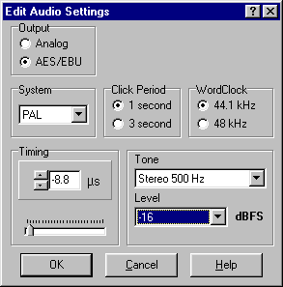##$$kk Edit|System

The System menu enables you to calibrate the main oscillator using this Windows® interface and fix all video output to the same TV system (NTSC/PAL), during a Factory Reset. Performing a Factory Reset replaces all current settings with the settings the unit has from factory and will not affect any of the four user presets.

Factory Reset:

Factory Reset overwrites all current settings with the settings the unit has from factory.
The reset is selectable between: NTSC,/525 or PAL/ 625

The factory settings:
- Internal reference
- No time advancing of Video outputs
- AES/EBU Audio at 48 kHz.

Note: Factory Reset will not affect the memory of any of the four user presets.

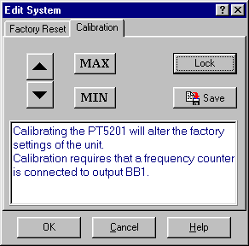
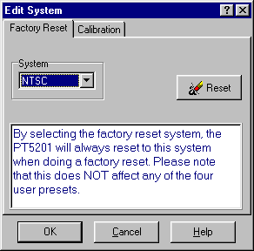

Calibration:
The calibration menu enables you to calibrate the unit without taking it out of a rack and out of service. The unit is calibrated using this Windows® interface and a general-purpose counter connected to the BB1 terminal. This calibration will effect the frequency of the main oscillator only; no other circuits need frequent calibration. To secure the factory calibration the unit is secured with a calibration lock function. To unlock and lock the calibration mode you enter Files/Properties/System.

Calibration procedure:
- Turn on the unit and connect it to a PC running the Windows® interface
- Connect a general purpose counter (better than 0.1ppm in tolerance) to BB1 output
- Unlock the calibration mode in Files/Properties/System and enter the calibration menu at Edit/System/Calibration
- Click on Unlock and expect a TTL clock at 4.5 MHz on the BB1 connector. There is now access to calibrate the main oscillator and using the up/down buttons to calibrate the BB1 outputs to 4,500,000 Hz.

- The calibration is stored in the unit by clicking on Save. By clicking on Cancel at any time before clicking on Save, the calibration mode will be terminated and the unit will hold the present calibration.

Note: Make sure to lock the calibration mode in Files/Properties/System to ensure no calibration is made by mistake.
##$$kk View|System Status

The System Status window will expand the Front Panel window and provide a view of settings of all outputs.
Besides information on timing, pattern and audio types and tones, the System Status gives information on unit serial no., SW release, Preset Status and serial communication (SCPI) status.
Editing of the settings is accessible by double click on each generator. By double click on a generator the corresponding generator window opens and enables editing.

The System Status window is not default and opens by checking System The settings are stored in an ini file on the used PC.

##$$kk View|Status Bar

Status Bar:
The Status Bar is default and is shown below the Front Panel or System Status window. This bar provides information on communications from the Windows® interface to the connected unit. The Status Bar states if a unit is present or not (connected/disconnected), which COM port is selected and the baud rate. Also it states if the Windows® interface is used in Demo Mode.

##$$kk Help

Not implemented in this version.
##$$kk Pop-up Topic

Pop-up topics allow you to give definitions of words, or brief explanations while keeping a normal topic open.

# IDH_ABOUT
$ About
k About
# IDH_FILESOPENFILE
$ Files
k Open from File
# IDH_FILESOPENPRESET
$ Files
k Open from Preset
# IDH_FILESSAVEFILE
$ Topic 4
k Save to File
# IDH_FILESSAVEPRESET
$ Topic 5
k Save to Preset
# IDH_FILESPRINT
$ Topic 6
k Print
# IDH_FILESPROPERTIES
$ Properties
k File properties
# IDH_CONNECTGENERATORSETTINGS
$ Connect Using Generator Settings
k Connect;Generator;Settings
# IDH_CONNECTPCSETTINGS
$ Connect Using PC Settings
k Connect;PC Settings
# IDH_CONNECTDISCONNECT
$ Connect
k Connect;Disconnect
# IDH_CONNECTDEMOMODE
$ Connect DEMO mode
k Connect;DEMO mode
# IDH_EDITGENLOCK
$ Edit Genlock
k Edit;Genlock settings
# IDH_EDITBB
$ Edit BB
k Edit;BB settings
# IDH_EDITTSG
$ Edit TSG
k Edit;TSG settings
# IDH_EDITAUDIO
$ Edit Audio
k Edit;Audio Settings
# IDH_EDITSYSTEM
$ Edit System
k Edit; System
# IDH_VIEWSYSTEMSTATUS
$ View
k View;System Status
# IDH_VIEWSTATUSBAR
$ View
k View;Status Bar
# IDH_HELP
$ Help
k Help
# IDH_TOPIC20
$ Pop-up
k Pop-up

